 | Elementary Breakfast September Menu  2023

MONDAY | TUESDAY | WEDNESDAY | THURSDAY | FRIDAY
CEjjjjjjjjjjjjjjjjjjjjjjjjjjjjjjjjjjjjjjjjjjjjjjjjjjjjjjjCearjjjjjjjjjjjjjjjjjjjjjjjjjjjjjjjjjjjjjjjjjjjjjjjjjjjjjjjjjjjjjjjjjjjjjjjjjjjan altern Cereal is available daily as an alternate ate le daily as an alternate Cereal is available daily as an alternate | Cereal is Available Daily |  |  |  | More Info…  Milk Choices:  Fat Free Chocolate  1% White Milk  All Breakfast items are available on our TWP BREAKFAST ON WHEELS Carts Served Throughout  Your School.  Price:  Adult: $3.00  Students: $2.50  A la carte:  Milk $.55  Juice $.50  
Welcome Back!!! | 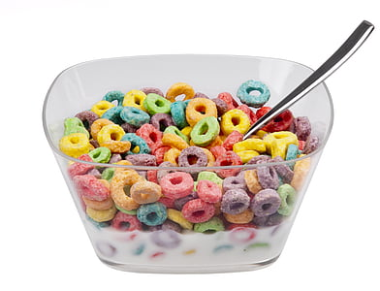 | 6  Mini Pancakes  Chilled Juice  Milk | 7  Assorted  Cereal Bars &  Chilled Yogurt  Assorted  Chilled Fruit  Milk | 8  Waffle Sandwich  w/ Chicken Sausage  & Cheese  Assorted  Chilled Fruit  Milk
11  Pancake & Fruit Bowl  Assorted  Chilled Fruit  Milk | 12  Mini Bagels w/ Strawberry  Cream Cheese  Chilled Juice  Milk | 13  Warmed  Cinnamon Roll  Assorted  Chilled Fruit  Milk | 14  Crunch Mania  Assorted  Chilled Juice  Milk | 15  Mini Blueberry Waffles  Assorted  Chilled Fruit  Milk
18  Mini  French Toast  Assorted  Chilled Fruit  Milk | 19  Turkey Sausage Wrapped in a Pancake  Assorted Chilled Fruit & Milk | 20  Bagel  w/ Cream Cheese  Assorted  Chilled Juice  Milk | 21  Assorted  Cereal Bars  Chilled Yogurt  Assorted  Chilled Fruit  Milk | 22  Assorted Muffins  with Yogurt  Assorted  Chilled Fruit  Milk
25  Chocolate Chip Waffle  Assorted  Chilled Juice  Milk | 26  Assorted Pop Tarts  & String Cheese  Assorted  Chilled Fruit  Milk | 27  Pancake & Fruit  Bowl  Assorted Chilled  Fruit  Milk | 28  Mini Bagels w/ Strawberry  Cream Cheese  Assorted  Chilled Juice  Milk | 29  Tony’s Egg, Sausage and Cheese Bagel  Assorted  Chilled Fruit  Milk

Washington Township Elementary Breakfast Menu
Meal Applications Now Available Online!  www.Payschoolscentral.com  856-582-4010 | Menus are subject to change without notice.

